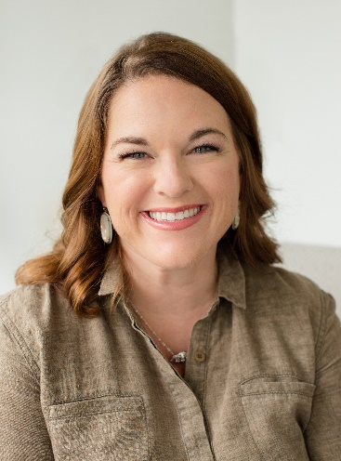
Lindsey Gray was first introduced to Komen through the Race for the Cure when it came to Little Rock 26 years ago. Her mom was diagnosed with breast cancer when she was 10 years old, so she has seen first-hand the struggle of treatment and celebrating surviving. She and her mom have done the race every year together to celebrate her mom, now a 29-year survivor. Lindsey came to Komen 3 years ago on a development task force and is committed to the mission of Susan G. Komen and raising funds and awareness here in Arkansas.

Aimee and Lindsey met while volunteering and enjoy working together on projects serving this community, so when Komen asked them to tackle a new concept in the More than Pink Walk, it was an easy yes. "We are excited to see the new format come to life! Getting back to the mission and having all those who attend be invested in raising money for research and care here in Arkansas will be a huge win for Komen Arkansas."

Lindsey is a life-long Little Rock resident, having been born and raised here. She is a graduate of Ouachita Baptist University with a degree in Accounting. Lindsey owns Eggshells Kitchen Co in Little Rock and serves in several volunteer roles. Her favorite role is wife to Brandon, and mom to three boys - Ethan, Charlie, and Harrison.

