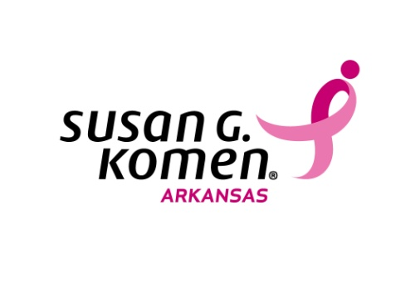
Outreach Request
Please submit request at least 6 weeks prior to the date of Event.
All requests must be approved by Komen staff.

Please email the completed form to mary.morrissey@baptist-health.org. Materials for approved requests will be available for pick-up at affiliate office, located in Little Rock. For more information, please call 501-202-4399.

Requested by: |  | Phone:
Email Address:
Requesting Organization:
Event Host/Sponsors: |  | Event Date:
Event Location: |  | Event Time:
Event Location cont: |  | Anticipated Number of Attendees
Event Address:

Request for: Education Materials Only |  | Presentation

Is the requesting organization one of the following (mark all that apply):
Non-profit |  | Faith based |  |  |  | Medical Provider |  | current Komen Arkansas grantee
State/Federal Agency |  |  |  | College/University |  |  |  | Other

Event Type (select one):
Health fair |  | Presentation/  Lunch & Learn |  | Education Materials Request |  | Other
Topic of General Interest (select one or more):
Breast Health |  | Breast Cancer |  |  |  | Survivorship |  | Affiliate Grants |  |  | Race for the Cure
Volunteer Opportunities |  |  |  | Fundraising Opportunities |  |  |  | Other
Target Audience (mark all that apply):
Women |  | African-American |  | unemployed |  | Breast cancer survivors
Men |  | Hispanic |  | working |  | co-survivors
Young Adults (18-25 yrs) |  | Caucasian |  | retired |  | general audience
Teens (12-16 yrs) |  | Other
Youth (7-12 yrs) |  |  |  | Other/Not listed

Notes/Purpose of Event:

